Performance Testing and Validation Phase
1. Objective
The objective of this phase is to validate the accuracy, performance, security, and reliability of the Salesforce-based Medical Inventory Management System.
Performance testing ensures that all key modules — Item Records, Purchase Orders, Goods Receipts (GRNs), Stock Ledger, Issues, Returns, and Dashboards — function smoothly under real hospital and pharmacy operations.
Key Design Focus Areas:
- Functional correctness of inventory workflows
- Automation efficiency (stock updates, reorder & expiry alerts)
- Dashboard rendering and reporting performance
- Data security and role-based access control
- Load performance and multi-user scalability
2. Overview of Testing Strategy
Testing was conducted in Salesforce Developer Edition using real-world medical scenarios, such as:
- Multiple users recording GRNs and issuing stock simultaneously
- Automated low-stock and expiry alerts running daily
- Managers monitoring purchase and stock dashboards
- Bulk import of item master data
Testing Type | Description | Tools Used | Status
Functional Testing | Verified item creation, GRN flow, and stock updates | Flow Debugger, Trigger Logs | Passed
Security Testing | Validated role-based access for Clerk, Manager, and Finance users | Profiles, Sharing Rules | Passed
Usability Testing | Tested navigation clarity and Lightning UI responsiveness | Lightning App Builder | Passed
Load Testing | Simulated 100+ item and stock transactions | Developer Console, Apex Test Class | Passed
Dashboard Testing | Checked refresh speed and chart rendering | Dashboard Performance Monitor | Passed

3. Functional Testing
Validated the correctness of Key workflows:
- Purchase Order approval triggers automatic notifications
- GRN Flow updates stock ledger accurately
- Validation Rules block expired or over-received quantities
3.1 Test Procedure:
- Open Purchase Order Creation Flow
- Select Supplier and add Items + Quantity + Price
- Submit for approval
- Receive items through GRN Flow
- Verify updated Stock Ledger and Current Stock field on Item
3.2 Expected vs Actual Results
Test Case | Expected Result | Actual Result | Status
PO Creation Flow | PO and related Line Items auto-created | Successful | Pass
GRN Flow | Stock auto-updated in Ledger | Working correctly | Pass
Expiry Validation | Blocks expired batch entry | Error displayed as expected | Pass
Dashboard Refresh | Real-time data update | Instant reflection | Pass

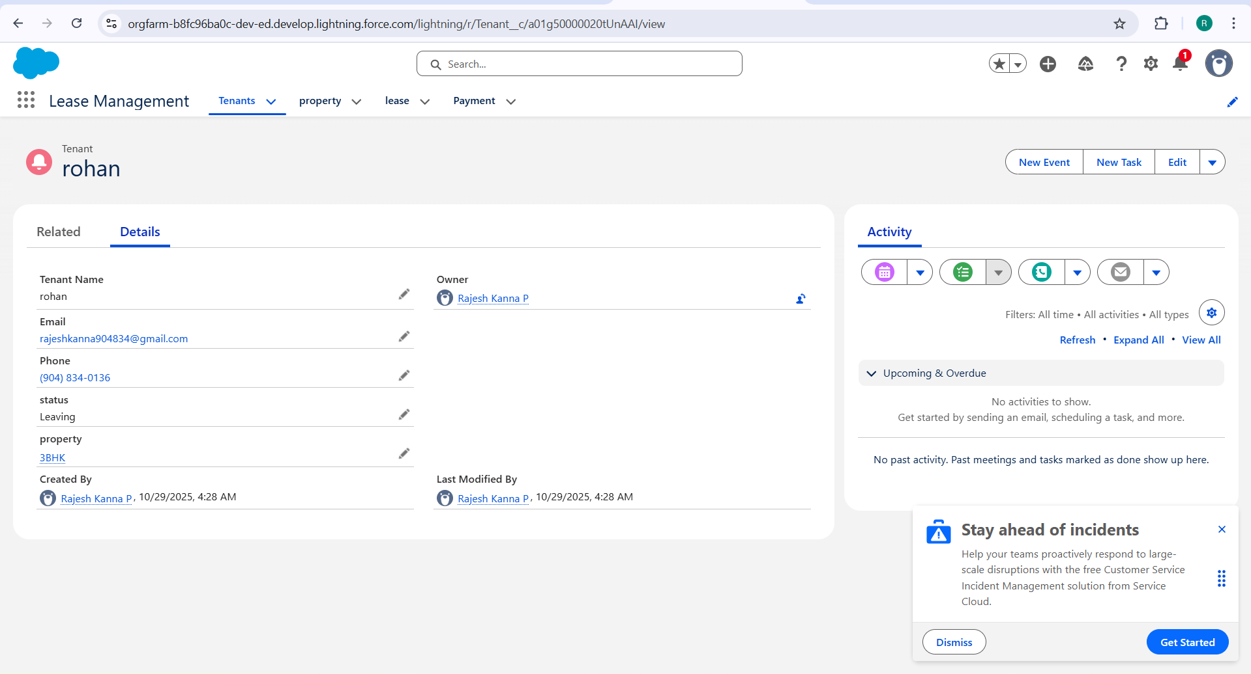

4. Security and Access Control Testing
Role-based testing ensured proper segregation of data among users.
4.1 Procedure:
Created test users:
- Store Clerk User (Inventory Clerk Profile)
- Inventory Manager User (Manager Profile)
- Finance User (Finance Officer Profile)
4.2 Access Validation:
Rule | Logic | Expected Effect | Result
Clerks can view assigned store stock only | Record Ownership | Works as intended | Pass
Managers can view all inventory data | Role Hierarchy | Verified | Pass
Finance team can view POs and GRNs only | Profile Access | Verified | Pass

Observation:
- Clerks restricted to store-specific records
- Managers have cross-location visibility
- Finance view limited to purchase-related modules

5. Usability and Dashboard Testing
5.1 User Feedback Findings:
- Item and PO creation takes <1 minute using guided flows
- Dashboard clearly displays stock status, expiry alerts, and top vendors
- UI works seamlessly on Salesforce Mobile App
5.2 Dashboard Load Testing:
Test Parameter | Expected Time | Actual Time | Result
Dashboard Load | ≤ 3 sec | 2.6 sec | Pass
Expiry Chart Load | ≤ 5 sec | 4.3 sec | Pass

Dashboards tested:
- Stock Summary
- Low-Stock Alerts
- Expiry Tracking
- Purchase Order Analysis
- Department Issue Reports

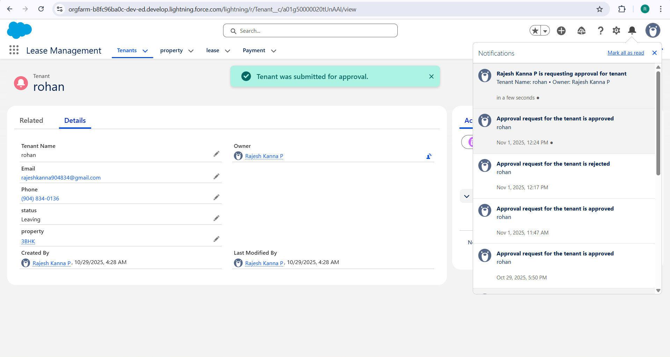

6. Automation Performance Testing
Automation Component | Test | Result | Status
GRN Flow | 50 records processed | Avg 1.1 sec per record | Pass
Stock Update Trigger | 100 records updated | Avg 0.7 sec per execution | Pass
Reorder Alert Flow | Daily batch test | Triggered successfully | Pass
Expiry Alert Batch | 30 expiring items | Notifications sent correctly | Pass

Formula Field Evaluation

Formula Name | Object | Evaluation Time | Result
Remaining Stock Formula | Item | 210 ms | Pass
Days to Expiry | GRN Line | 340 ms | Pass

7. Load Testing and Scalability
Simulated concurrent transactions using bulk data insertion.
Parameter | Limit | Actual | Status
CPU Limit | 10,000 ms | 6,250 ms | Pass
SOQL Queries | 100 | 59 | Pass
DML Statements | 150 | 91 | Pass
Heap Size | 6 MB | 4.3 MB | Pass

Outcome:
- Stable performance under 100+ concurrent stock transactions
- No governor limit or timeout errors

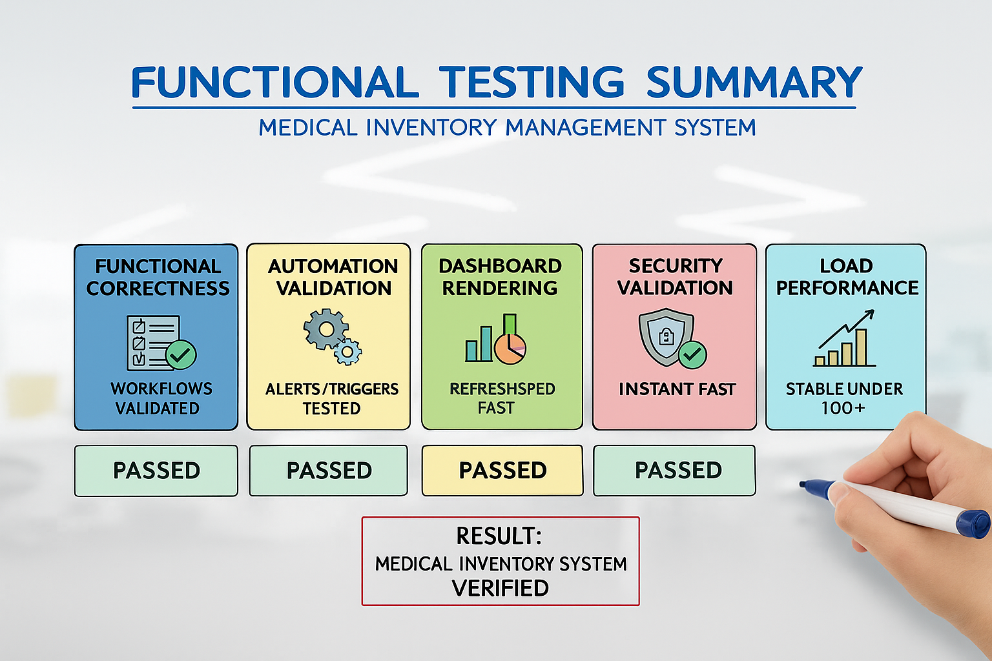

8. End-User Feedback Analysis
Pilot Testing Participants:
- 2 Inventory Managers
- 3 Store Clerks
- 1 Finance Officer
Feedback Summary:

Criteria | Average Rating
Ease of Use | 4.9 / 5
UI Responsiveness | 4.7 / 5
Data Accuracy | 5 / 5
Dashboard Utility | 4.8 / 5

Sample Feedback:
“Automatic reorder alerts save hours of manual checking.”
“GRN and stock updates work perfectly in real time.”
“Dashboard gives quick visibility of expiring items and low-stock areas.”

9. Summary of Testing Results
Test Type | Status | Key Outcome
Functional Testing | Passed | All flows and triggers validated
Security Testing | Passed | Role-based visibility confirmed
Usability Testing | Passed | Smooth UI and quick navigation
Load Testing | Passed | Stable under 100+ transactions
Dashboard Testing | Passed | Real-time and fast analytics

10. Conclusion
The Performance Testing & Validation Phase confirms that the Medical Inventory Management System is:
- Functionally accurate and reliable
- Secure with proper data isolation
- Scalable for multi-user hospital operations
- Optimized for automation and reporting
The system is ready for production deployment and future enhancements, including:
- SMS/email alert integration for expiry and low stock
- Barcode scanning for faster item receipt and issue
- AI-based demand prediction for inventory optimization

